Insert School Logo

PSYCHOLOGY
ATAR YEAR 11
UNIT 1 2021
Question/Answer Booklet

Name: _______________________________________________________

Teacher: _____________________________________________________

Time allowed for this paper
Reading/planning time before commencing work: ten minutes
Working time for paper: three hours

Material required/recommended for this paper

To be provided by the supervisor
This Question/Answer Booklet

To be provided by the candidate
Standard materials: pens (blue/black preferred), pencils (including coloured), sharpener, eraser, correction fluid/tape, ruler, and highlighters

Special items: non-programmable calculators approved for use in the WACE examinations

Important note to candidates
No other materials may be taken into the examination room. It is your responsibility to ensure that you do not have any unauthorised notes or other items of a non-personal nature in the examination room. If you have any unauthorised material with you, hand it to the supervisor before reading any further.

Structure of this paper

Section | Number of questions available | Number of questions to be attempted | Suggested working time  (minutes) | Marks | Percentage of exam
Section One:  Research methods | 3 | 3 | 30 | 30 | 20
Section Two:  Short answer | 6 | 6 | 90 | 96 | 55
Section Three:  Extended answer | 2 | 2 | 60 | 52 | 25
 |  |  | Total |  | 100

Instructions to candidates
- The rules for the conduct of Western Australian external examinations are detailed in the Year 11 Information Handbook 2021. Sitting this examination implies that you agree to abide by these rules.

- Write your answers in this Question/Answer Booklet.

- You must be careful to confine your responses to the specific questions asked and to follow any instructions that are specific to a particular question.

- Spare pages are included at the end of this booklet. They can be used for planning your responses and/or as additional space if required to continue an answer.

- Planning: If you use the spare pages for planning, indicate this clearly at the top of the page.
- Continuing an answer: If you need to use the space to continue an answer, indicate in the original answer space where the answer is continued, i.e. give the page number. Fill in the number of the question that you are continuing to answer at the top of the page.

Section One: Research Methods 20% (30 marks)
This section has three questions. Answer all questions. Write your answers in the spaces provided.
Supplementary pages for planning/continuing your answers to questions are provided at the end of this Question/Answer booklet. If you use these pages to continue an answer, indicate at the original answer where the answer is continued, i.e. give the page number.
Suggested working time: 30 minutes ________________________________________________________________
Question 1 (11 marks)

Forty participants were tasked with learning a list of 20 words while listening to music. An hour later, the participants were randomly allocated into two equal size groups and their recall ability was assessed when they were asked to recall the list of words. Group one completed their recall while listening to the same music played at the beginning of the study, while Group two recalled the words in silence. The table below shows the results collected.

 | Group one | Group two
Mean | 16 | 10
Range | 8 | 12

(a) Comment on the spread of scores for each of the two groups. (1 mark)

____________________________________________________________________________________________________________________________________________________________
______________________________________________________________________________

(b) Write a suitable operationalised hypothesis for this study. (4 marks)

____________________________________________________________________________________________________________________________________________________________
______________________________________________________________________________
______________________________________________________________________________
______________________________________________________________________________

______________________________________________________________________________
______________________________________________________________________________
Question 1 (continued)

(c) Outline two benefits of randomly allocating participants into each group. (2 marks)

One: _________________________________________________________________________
______________________________________________________________________________
______________________________________________________________________________

Two: _________________________________________________________________________
______________________________________________________________________________
______________________________________________________________________________

(d) There were two groups, one for each condition of the independent variable. Explain two reasons why this is an advantage of the study, rather than having all participants exposed to both conditions (having to recall the words while listening to music and then again without music). (4 marks)

____________________________________________________________________________________________________________________________________________________________
______________________________________________________________________________
____________________________________________________________________________________________________________________________________________________________
______________________________________________________________________________

Question 2 (13 marks)

A personal trainer wanted to investigate whether the tempo of music listened to while walking affected the speed at which people walk. She predicted that the faster the tempo of music listened to, the faster the person would walk. The personal trainer used beats per minute (bpm) as a measure of music tempo and recorded the distance (km) that 20 seventeen-year-old students walked for one hour on a treadmill. Five students were allocated into four different conditions, their results shown in the table below.

Condition | Average distance walked (km)
Condition one: walking without listening to music | 3
Condition two: walking listening to music at 40-70 bpm | 2.5
Condition three: walking listening to music at 85-110 bpm | 4
Condition four: walking listening to music at 120-140 bpm | 5.5

(a) Graph the results from the above information into the grid below. (5 marks)

A spare grid is provided at the end of this Question/Answer booklet.
If you need to use it, cross out this attempt.


Question 2 (continued)

(b) A statistical test found that the difference between condition 3 and 4 was
statistically significant. Explain what this means. (2 marks)

______________________________________________________________________________
______________________________________________________________________________

______________________________________________________________________________

(c) Outline two ways that the reliability of the experiment could be increased.
(2 marks)

One: __________________________________________________________________________

______________________________________________________________________________

Two: __________________________________________________________________________

______________________________________________________________________________

(d) Identify two ethical considerations related to this experiment and explain why the personal trainer should take them into consideration. (4 marks)

One: _________________________________________________________________________
______________________________________________________________________________
______________________________________________________________________________
______________________________________________________________________________

Two: _________________________________________________________________________
______________________________________________________________________________
______________________________________________________________________________

______________________________________________________________________________

Question 3 (6 marks)
Miss Kicisnski had her small group of students sit a 20-mark test after no revision and then another test after allowing them two hours of revision. Their test results are shown in the table below.

Participant | Score on test without revision | Score on test after 2 hours of revision
1 | 11 | 15
2 | 6 | 17
3 | 8 | 20
4 | 10 | 14
5 | 7 | 12
(a) i. Calculate the mean score for participants who did no revision before their test,
giving the answer correct to one decimal place. (1 mark)

_____________________________________________________________________

ii. Calculate the median score for participants who did 2 hours of revision before
their test. (1 mark)

_____________________________________________________________________

(b) State whether Miss Kicinski’s research is experimental or non-experimental and provide one reason for your response. (2 marks)

____________________________________________________________________________________________________________________________________________________________
____________________________________________________________________________________________________________________________________________________________

Question 3 (continued)

(c) The data collected for the research was quantitative.

i. Provide one benefit of collecting quantitative data. (1 mark)

_____________________________________________________________________

_____________________________________________________________________

ii. Provide one benefit of collecting qualitative data. (1 mark)

_____________________________________________________________________

_____________________________________________________________________

End of Section One
Section Two: Short Answer 55% (96 marks)
This section has six questions. Answer all questions. Write your answers in the spaces provided.
Supplementary pages for planning/continuing your answers to questions are provided at the end of this Question/Answer booklet. If you use these pages to continue an answer, indicate at the original answer where the answer is continued, i.e. give the page number.

Suggested working time: 90 minutes
________________________________________________________________
Question 4 (17 marks)

In the Netflix drama, The Queen’s Gambit, the main character is Beth, a chess prodigy who strives to become the greatest chess player in the world. The game of chess requires skills that are dominantly controlled by the left or right cerebral hemispheres in the brain.

(a) For the following examples, identify whether the left or right hemisphere is more
dominant.

i. Recognising that the chess board has a pattern of dark and light squares.
(1 mark)
_____________________________________________________________________

ii. The abstract reasoning required when working out which piece to move (if I
move my rook here, then I can take out his bishop). (1 mark)

_____________________________________________________________________

iii. Visualising in your mind a combination of moves to make on the board.
(1 mark)

_____________________________________________________________________

iv. Moving a chess piece with your left hand. (1 mark)

_____________________________________________________________________

Question 4 (continued)

(b) Describe the location of the cerebral cortex in the brain. (2 marks)

______________________________________________________________________________

______________________________________________________________________________

(c) Describe the physical structure of the corpus callosum. (1 mark)

______________________________________________________________________________

(d) i. Using the diagram below, identify the part of Phineas Gage’s brain that
sustained most of the damage during his accident (shade in or draw a line
around the part). (1 mark)

ii. Name the research method used to study one person, such as Phineas Gage,
or a small group of people. (1 mark)

_____________________________________________________________________

Question 4 (continued)

(e) Describe the path messages take when travelling through a sending (presynaptic) neuron to a receiving (post synaptic) neuron. (4 marks)

______________________________________________________________________________

______________________________________________________________________________

______________________________________________________________________________

______________________________________________________________________________

______________________________________________________________________________

______________________________________________________________________________

(f) i. Explain how fast-growing tissues in the brain, such as cancerous tumours, are
detected by the positron emission tomography scan (PET). (2 marks)

_____________________________________________________________________

_____________________________________________________________________

_____________________________________________________________________

_____________________________________________________________________

ii. Outline two differences between an MRI scan and fMRI scan. (2 marks)

One: ________________________________________________________________

_____________________________________________________________________

_____________________________________________________________________

_____________________________________________________________________

Two: ________________________________________________________________

_____________________________________________________________________

_____________________________________________________________________

_____________________________________________________________________

Question 5 (14 marks)

(a) Explain two ways in which exercise can affect emotion. (4 marks)

• ___________________________________________________________________________

___________________________________________________________________________

____________________________________________________________________________

• ___________________________________________________________________________

___________________________________________________________________________

____________________________________________________________________________

(b) i. Comment on the effect that recreational drugs have on perception. (1 mark)

_____________________________________________________________________

_____________________________________________________________________

ii. Name one recreational drug that may cause the effect described in part (i).
(1 mark)

_____________________________________________________________________

Question 5 (continued)

(c) Complete the table below. (8 marks)

 | Amphetamine | Alcohol
Class of drug

Effect on central nervous system

Effect on breathing rate

Effect on confidence levels

Question 6 (16 marks)

When viewing stimuli, part of the image projected onto the retina of the eye is obstructed by the spot at which the optical nerve joins the retina. This spot is known as the ‘blind spot’.

(a) Name the process that allows the brain to fill the gap formed by the blind spot and
form a whole coherent image. (1 mark)

______________________________________________________________________________

(b) Outline one reason why psychologists study illusions. (1 mark)

______________________________________________________________________________

______________________________________________________________________________

(c) Is the image below shifting between a rabbit and duck due to it being a visual illusion, or is it due to a shift in attention? Explain your response. (3 marks)
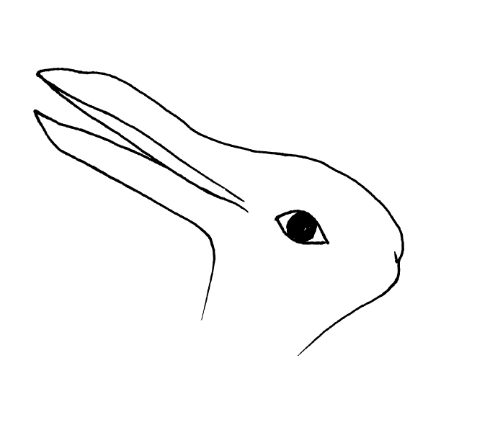

______________________________________________________________________________

______________________________________________________________________________

______________________________________________________________________________

______________________________________________________________________________

______________________________________________________________________________

Question 6 (continued)

(d) i. List the two main categories of consciousness. (2 marks)

• _____________________________________________________________________

• _____________________________________________________________________

ii. State one example of an altered state of consciousness that occurs naturally
and one example of an altered state of consciousness that can be induced.
(2 marks)

Naturally occurring: ____________________________________________________

Induced: _____________________________________________________________

(e) i. A nurse is wanting to check whether a patient has been anaesthetised and is
ready for surgery. Name one physiological measure the nurse could use in
order to determine the station of consciousness of the patient. (1 mark)

_____________________________________________________________________

ii. Outline the reading likely to be shown by the physiological measure named in
part (i) if the patient has in fact been anaesthetised. (1 mark)

_____________________________________________________________________

_____________________________________________________________________

(f) There are certain recreational drugs that can cause the user to enter a drug-induced state of consciousness where the heart rate increases above normal levels. Identify one such drug. (1 mark)

______________________________________________________________________________

(g) A researcher investigating attention set up a number of trials using a mouse
placed inside a cage with one side made of clear perspex allowing for the mouse
to be observed.

i. Through a small speaker in the cage, a large ‘bang’ was sounded and the
mouse jumped in shock. Describe the behaviour of the mouse after the
banging noise was sounded 5 or 6 times over a minute. (1 mark)
_____________________________________________________________________

Question 6 (continued)

ii. Name the process that is described in part (i). (1 mark)

________________________________________________________________

iii. A few minutes later a new sound, a shrill ‘ding’ noise, is made. Describe the
behaviour that the researcher would likely observe in the mouse. (1 mark)

________________________________________________________________

iv. Name the process that is described in part (iii). (1 mark)
______________________________________________________________________

Question 7 (18 marks)

(a) A psychologist is providing therapy to a new client, Chris, who was encouraged by
his girlfriend to attend, but who is not particularly open to the experience.

i. As the psychologist asks Chris questions, he is not replying to her in detail,
however, he is making gestures as he speaks. Explain how Chris’ gestures
can help the psychologist provide him with beneficial therapy.
(2 marks)

_____________________________________________________________________

_____________________________________________________________________

_____________________________________________________________________

_____________________________________________________________________

ii. There are many examples of gestures that humans use when communicating,
whether or not they are aware they are making them. List three examples of
gestures. (3 marks)

• __________________________________________________________________

• __________________________________________________________________

• __________________________________________________________________

(b) There are some facial expressions that can help humans to survive. When showing fear, pupils dilate and the mouth is open. Explain how dilated pupils and an open mouth would improve the survival rate of a human in danger. (4 marks)

_____________________________________________________________________________

______________________________________________________________________________

______________________________________________________________________________

______________________________________________________________________________

______________________________________________________________________________

______________________________________________________________________________

Question 7 (continued)

(c) Explain why sign language, such as Auslan, is not considered ‘body language’.
(2 marks)

______________________________________________________________________________

______________________________________________________________________________

______________________________________________________________________________

(d) Robinson published a book in 2003 which drew attention to the different ways
adults communicate socially.

i. Name the nonverbal social skill addressed by Robinson. (1 mark)

_____________________________________________________________________

ii. According to Robinson, using politeness as a behaviour when communicating
requires two concepts that need to be taken into account. Outline these two
concepts. (2 marks)

One: ________________________________________________________________

_____________________________________________________________________

_____________________________________________________________________

Two: ________________________________________________________________

_____________________________________________________________________

_____________________________________________________________________

(e) Define the term ‘hearing impairment’. (1 mark)

______________________________________________________________________________

______________________________________________________________________________

Question 7 (continued)

(f) Annie is 8-years-old and presents with language delays due to having a mild
intellectual disability. Outline three ways that the delay in her language skills would
affect her development in primary school. (3 marks)

• ___________________________________________________________________________

___________________________________________________________________________

• ___________________________________________________________________________

___________________________________________________________________________

• ___________________________________________________________________________

___________________________________________________________________________

Question 8 (17 marks)

(a) Explain why it is difficult to define ‘intelligence’. (2 marks)

____________________________________________________________________________________________________________________________________________________________
______________________________________________________________________________

(b) The multiple intelligences theory claims that there are numerous intelligences that
each person possesses.

i. Name the theorist who developed this theory. (1 mark)

_____________________________________________________________________

ii. Contrast between intrapersonal intelligence and interpersonal intelligence.
(2 marks)

_____________________________________________________________________

_____________________________________________________________________

_____________________________________________________________________

_____________________________________________________________________

iii. Describe how multiple intelligences can be used by primary school teachers in
the classroom. (1 mark)

_____________________________________________________________________

_____________________________________________________________________

Question 8 (continued)

(c) Below is a diagram used to describe the two-factor theory.
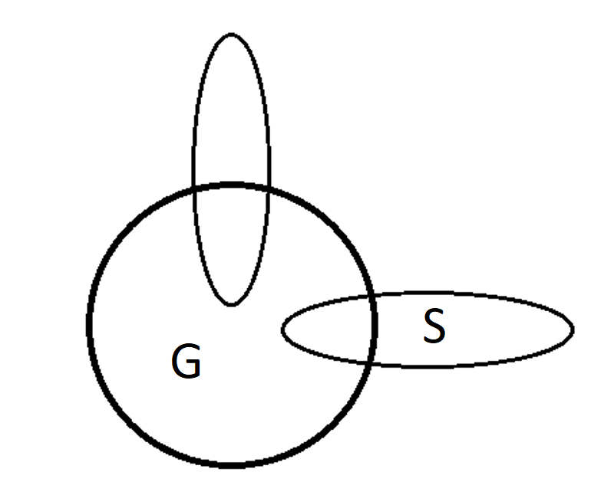

i. Identify what part ‘G’ in the diagram refers to. (1 mark)

_____________________________________________________________________

ii. Identify what part ‘S’ in the diagram refers to. (1 mark)

_____________________________________________________________________

iii. Name the theorist who developed the two-factor theory of intelligence.
(1 mark)

_____________________________________________________________________

iv. The theorist named in part (iii) administered a range of tests on children and
found scores on tests, such as maths and logical reasoning, had strong
positive correlations with each other. Explain what this means. (2 marks)

_____________________________________________________________________

_____________________________________________________________________

_____________________________________________________________________

_____________________________________________________________________

Question 8 (continued)

(d) i. Name the model of intelligence developed by Wechsler. (1 mark)

_____________________________________________________________________

ii. Wechsler produced tests for both children and adults that formed a score.
Name the score that was produced. (1 mark)

_____________________________________________________________________

_____________________________________________________________________

(e) Individual intelligence testing requires the examiner to build rapport with the test
taker. Outline how this may be a benefit of individual intelligence testing as well as
be seen as a limitation. (2 marks)

Advantage: ___________________________________________________________________
______________________________________________________________________________

______________________________________________________________________________

Disadvantage: _________________________________________________________________
______________________________________________________________________________

______________________________________________________________________________

(f) Explain why scores are generally dependent on reading ability in group intelligence
tests, while in individual intelligence tests, scores are not generally dependent on
reading ability. (2 marks)

____________________________________________________________________________________________________________________________________________________________
______________________________________________________________________________

______________________________________________________________________________

Question 9 (14 marks)

(a) Popular Australian research on the formation of adolescent groups suggests that
peer groups change over time and move through a number of distinct stages.

i. Identify the number of stages theorised in the research. (1 mark)

_______________________________________________________________

ii. At which stage does group membership require a degree of conformity among
members? (1 mark)

_____________________________________________________________________

iii. Which stage is made up numerous couples that spend time together?
(1 mark)

_____________________________________________________________________

iv. During which stage does dating between adolescents occur? (1 mark)

_____________________________________________________________________

(b) Provide two reasons why bullying is a form of anti-social behaviour. (2 marks)

One: _________________________________________________________________________
______________________________________________________________________________

Two: _________________________________________________________________________
______________________________________________________________________________

Question 9 (continued)

(c) Outline two characteristics of pro-social behaviour. (2 marks)

• ___________________________________________________________________________

___________________________________________________________________________

• ___________________________________________________________________________

___________________________________________________________________________

(d) Empathy is one aspect of pro-social behaviour that is believed to be a motivation
for people to help others.

i. Using an example, describe the term ‘empathy’ and explain how it could lead
someone to want to help another person. (3 marks)

_____________________________________________________________________

_____________________________________________________________________

_____________________________________________________________________

_____________________________________________________________________

_____________________________________________________________________

_____________________________________________________________________

_____________________________________________________________________

Question 9 (continued)

ii. Vincent is 3-months-old and cries when he requires his needs to be met.
Explain why his survival is partially dependent on his primary caregiver having
the ability to feel empathy. (3 marks)

_____________________________________________________________________

_____________________________________________________________________

_____________________________________________________________________

_____________________________________________________________________

_____________________________________________________________________

_____________________________________________________________________

_____________________________________________________________________

End of Section Two
Section Three: Extended Answer 25% (52 marks)
Section three consists of two questions. You must answer both questions.
Supplementary pages for planning/continuing your answers to questions are provided at the end of this Question/Answer booklet. If you use these pages to continue an answer, indicate at the original answer where the answer is continued, i.e. give the page number.

Suggested working time: 60 minutes.

Write your answer to Question 10 on pages 27-32. When you have answered this question, turn to page 33 for Question 11 and write your answer on pages 34-39.

Question 10 (26 marks)

Year 12 students, Christine and Adelle, met at the Pulse Perspectives exhibition of year 12 art work at the Art Gallery of WA. They started chatting after Adelle complimented Christine on the dress she was wearing and after a few hours discussing the exhibited art together, they exchanged numbers and agreed to meet for coffee the following week. As Christine had her licence and Adelle only lived 10 minutes away, she gave Christine a lift to the café and in return, Adelle paid for Christine’s coffee and cake at the café. Over time, they became close friends.

In your answer you should:

- Define the term ‘liking’.
- Name and outline the three determinants of liking.
- Provide an example of how each determinant of liking can be seen between Christine and Adelle.
- Comment on the type of behaviour demonstrated by both Christine and Adelle.
- Name the researcher and research method that is commonly associated with studying adolescent peer group structure.
- List and outline the three levels of peer groups in adolescence and identify the level that relates to Christine and Adelle.
- Refer to psychological evidence and understandings.

Question number: ___________
__________________________________________________________________________________________________________________________________________________________________________________________________________________________________________________________________________________________________________________________________________________________________________________________________________________________________________________________________________________________________________________________________________________________________________________________________________________________________________________________________________________________________________________________________________________________________________________________________________________________________________________________________________________________________________________________________________________________________________________________________________________________________________________________________________________________________________________________________________________________________________________________________________________________________________________________________________________________________________________________________________________________________________________________________________________________________________________________________________________________________________________________________________________________________________________________________________________________________________________________________________

Question number: ___________
__________________________________________________________________________________________________________________________________________________________________________________________________________________________________________________________________________________________________________________________________________________________________________________________________________________________________________________________________________________________________________________________________________________________________________________________________________________________________________________________________________________________________________________________________________________________________________________________________________________________________________________________________________________________________________________________________________________________________________________________________________________________________________________________________________________________________________________________________________________________________________________________________________________________________________________________________________________________________________________________________________________________________________________________________________________________________________________________________________________________________________________________________________________________________________________________________________________________________________________________________________

Question number: ___________
__________________________________________________________________________________________________________________________________________________________________________________________________________________________________________________________________________________________________________________________________________________________________________________________________________________________________________________________________________________________________________________________________________________________________________________________________________________________________________________________________________________________________________________________________________________________________________________________________________________________________________________________________________________________________________________________________________________________________________________________________________________________________________________________________________________________________________________________________________________________________________________________________________________________________________________________________________________________________________________________________________________________________________________________________________________________________________________________________________________________________________________________________________________________________________________________________________________________________________________________________________

Question number: ___________
__________________________________________________________________________________________________________________________________________________________________________________________________________________________________________________________________________________________________________________________________________________________________________________________________________________________________________________________________________________________________________________________________________________________________________________________________________________________________________________________________________________________________________________________________________________________________________________________________________________________________________________________________________________________________________________________________________________________________________________________________________________________________________________________________________________________________________________________________________________________________________________________________________________________________________________________________________________________________________________________________________________________________________________________________________________________________________________________________________________________________________________________________________________________________________________________________________________________________________________________________________

Question number: ___________
__________________________________________________________________________________________________________________________________________________________________________________________________________________________________________________________________________________________________________________________________________________________________________________________________________________________________________________________________________________________________________________________________________________________________________________________________________________________________________________________________________________________________________________________________________________________________________________________________________________________________________________________________________________________________________________________________________________________________________________________________________________________________________________________________________________________________________________________________________________________________________________________________________________________________________________________________________________________________________________________________________________________________________________________________________________________________________________________________________________________________________________________________________________________________________________________________________________________________________________________________________
Question number: ___________
__________________________________________________________________________________________________________________________________________________________________________________________________________________________________________________________________________________________________________________________________________________________________________________________________________________________________________________________________________________________________________________________________________________________________________________________________________________________________________________________________________________________________________________________________________________________________________________________________________________________________________________________________________________________________________________________________________________________________________________________________________________________________________________________________________________________________________________________________________________________________________________________________________________________________________________________________________________________________________________________________________________________________________________________________________________________________________________________________________________________________________________________________________________________________________________________________________________________________________________________________________

Question 11 (26 marks)

In the 1960s, Paul Ekman visited people from different cultures and took photographs of their expressions given when presented with scenarios. He then asked participants from around the world to identify the emotions shown in the photographs and discovered that more than 90% of expressions were recognised around the world. Ekman theorised six common facial expressions that are recognised universally.

The ability to recognise facial expressions allows for the emotions of people around us to be identified. Emotional intelligence (EQ) became popularised in the late 1990s and many believe it is as important as IQ for social, academic and professional success.

In your answer you should:

- Name the type of communication facial expressions are categorised under.
- Define the term ‘facial expression’.
- List four common facial expressions that are universally recognised.
- Name the theorist who popularised EQ theory in the late 1990s.
- Outline the three main concepts that make up EQ.
- Suggest two reasons why many people believe EQ is a valuable skill that leads to success in the workplace.
- Define the term ‘active listening’ and, considering an individual with high EQ, provide two examples to show how they could actively listen to another person.
- Refer to psychological evidence and understandings.

End of questions

Question number: ___________
________________________________________________________________________________________________________________________________________________________________________________________________________________________________________________________________________________________________________________________________________________________________________________________________________________________________________________________________________________________________________________________________________________________________________________________________________________________________________________________________________________________________________________________________________________________________________________________________________________________________________________________________________________________________________________________________________________________________________________________________________________________________________________________________________________________________________________________________________________________________________________________________________________________________________________________________________________________________________________________________________________________________________________________________________________________________________________________________________________________________________________________________________________________________________________________________________________________________________________________________________________________________________________________________________________
Question number: ___________
__________________________________________________________________________________________________________________________________________________________________________________________________________________________________________________________________________________________________________________________________________________________________________________________________________________________________________________________________________________________________________________________________________________________________________________________________________________________________________________________________________________________________________________________________________________________________________________________________________________________________________________________________________________________________________________________________________________________________________________________________________________________________________________________________________________________________________________________________________________________________________________________________________________________________________________________________________________________________________________________________________________________________________________________________________________________________________________________________________________________________________________________________________________________________________________________________________________________________________________________________________

Question number: ___________
__________________________________________________________________________________________________________________________________________________________________________________________________________________________________________________________________________________________________________________________________________________________________________________________________________________________________________________________________________________________________________________________________________________________________________________________________________________________________________________________________________________________________________________________________________________________________________________________________________________________________________________________________________________________________________________________________________________________________________________________________________________________________________________________________________________________________________________________________________________________________________________________________________________________________________________________________________________________________________________________________________________________________________________________________________________________________________________________________________________________________________________________________________________________________________________________________________________________________________________________________________

Question number: ___________
__________________________________________________________________________________________________________________________________________________________________________________________________________________________________________________________________________________________________________________________________________________________________________________________________________________________________________________________________________________________________________________________________________________________________________________________________________________________________________________________________________________________________________________________________________________________________________________________________________________________________________________________________________________________________________________________________________________________________________________________________________________________________________________________________________________________________________________________________________________________________________________________________________________________________________________________________________________________________________________________________________________________________________________________________________________________________________________________________________________________________________________________________________________________________________________________________________________________________________________________________________

Question number: ___________
__________________________________________________________________________________________________________________________________________________________________________________________________________________________________________________________________________________________________________________________________________________________________________________________________________________________________________________________________________________________________________________________________________________________________________________________________________________________________________________________________________________________________________________________________________________________________________________________________________________________________________________________________________________________________________________________________________________________________________________________________________________________________________________________________________________________________________________________________________________________________________________________________________________________________________________________________________________________________________________________________________________________________________________________________________________________________________________________________________________________________________________________________________________________________________________________________________________________________________________________________________
Question number: ___________
__________________________________________________________________________________________________________________________________________________________________________________________________________________________________________________________________________________________________________________________________________________________________________________________________________________________________________________________________________________________________________________________________________________________________________________________________________________________________________________________________________________________________________________________________________________________________________________________________________________________________________________________________________________________________________________________________________________________________________________________________________________________________________________________________________________________________________________________________________________________________________________________________________________________________________________________________________________________________________________________________________________________________________________________________________________________________________________________________________________________________________________________________________________________________________________________________________________________________________________________________________
Additional working space
__________________________________________________________________________________________________________________________________________________________________________________________________________________________________________________________________________________________________________________________________________________________________________________________________________________________________________________________________________________________________________________________________________________________________________________________________________________________________________________________________________________________________________________________________________________________________________________________________________________________________________________________________________________________________________________________________________________________________________________________________________________________________________________________________________________________________________________________________________________________________________________________________________________________________________________________________________________________________________________________________________________________________________________________________________________________________________________________________________________________________________________________________________________________________________________________________________________________________________________________________________

Question 2(a)



